Fatima Jinnah Women University

***Department of Software Engineering***

|  |
| --- |
|  |
|  |  |

**SUBJECT: CC LAB**

**SUBMITTED TO: SIR SHOAIB**

**SUBMITTED BY: ZUNAIRA NOOR**

**REGISTRATION NO: 2023-BSE-075**

**SEMESTER: V-B**

**Task 1 — Create an AWS account and enable UAE (me-central-1)**

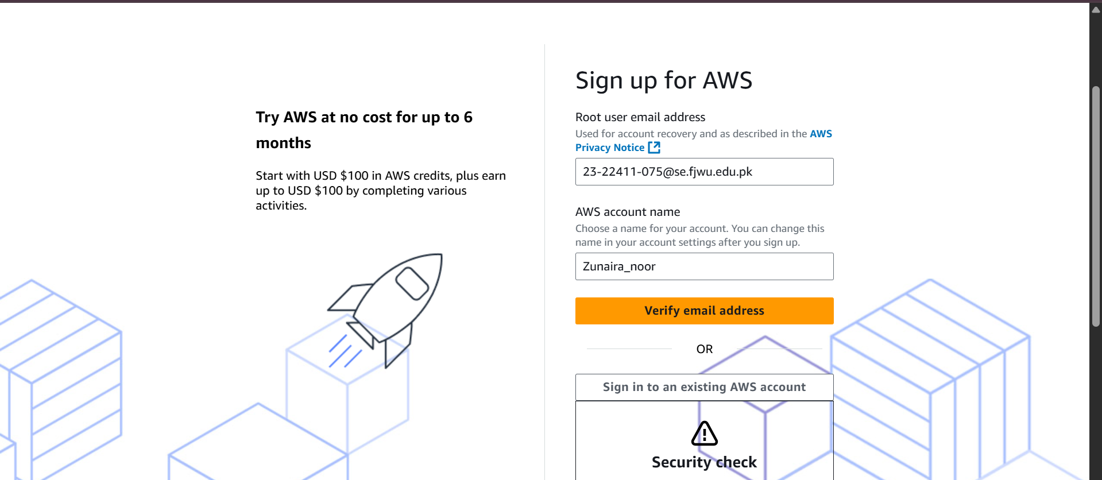

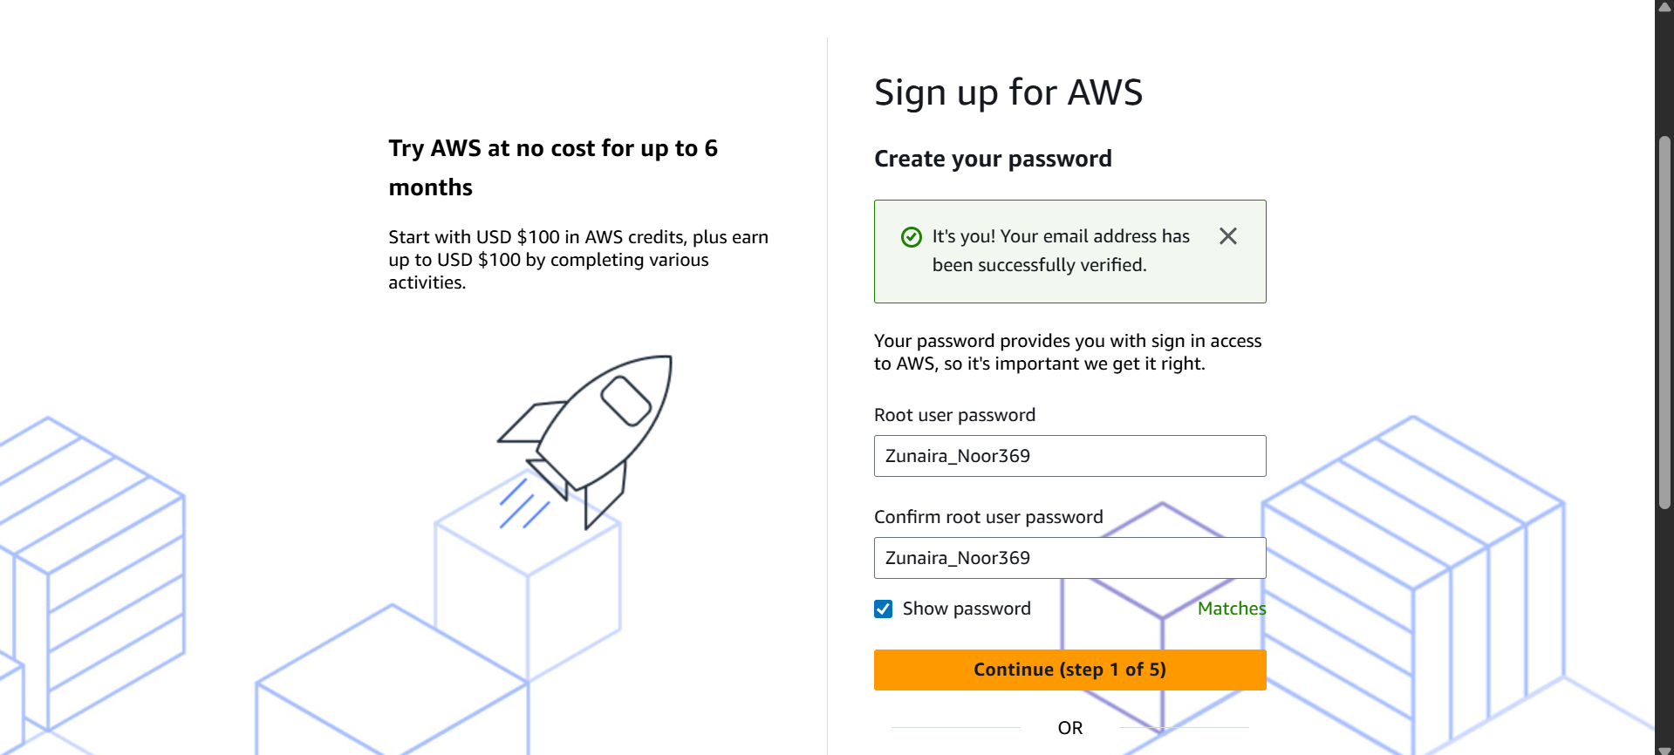

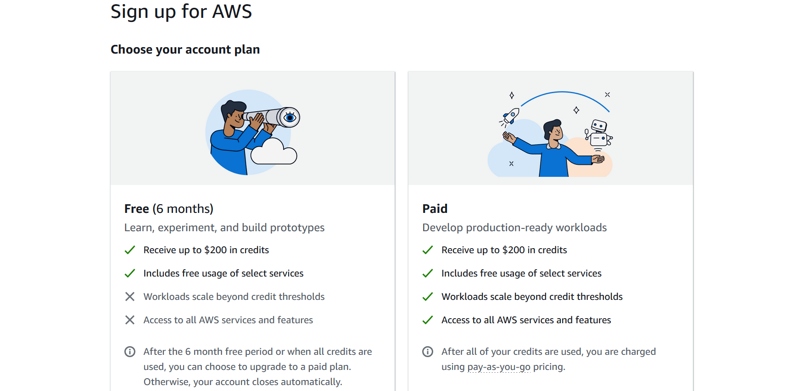

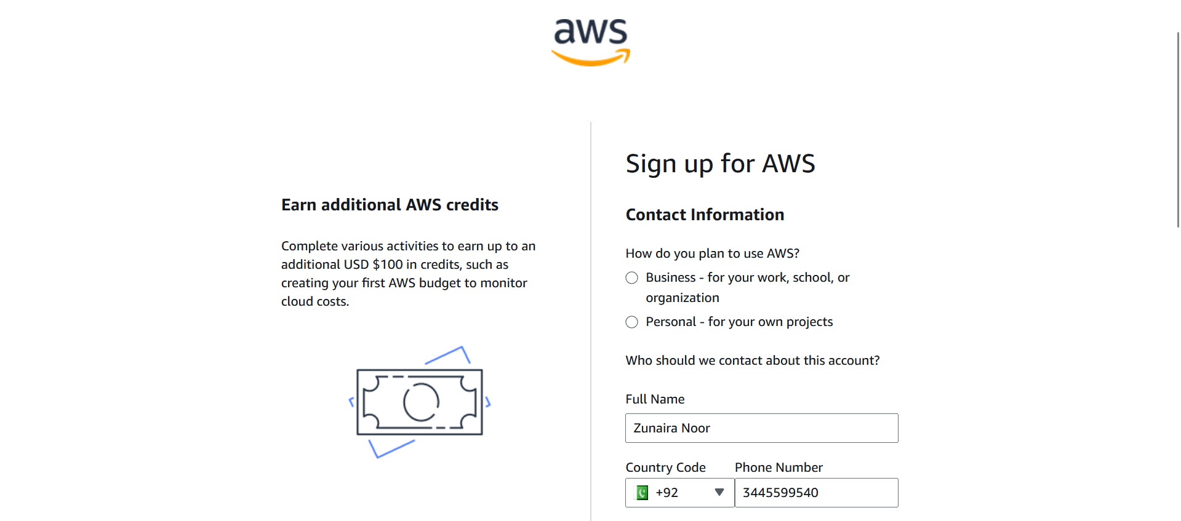

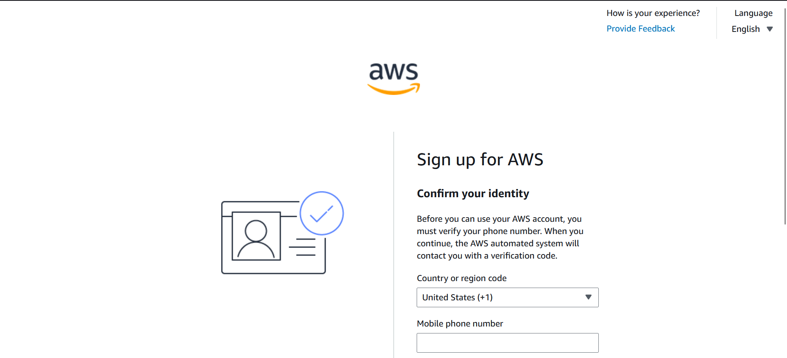

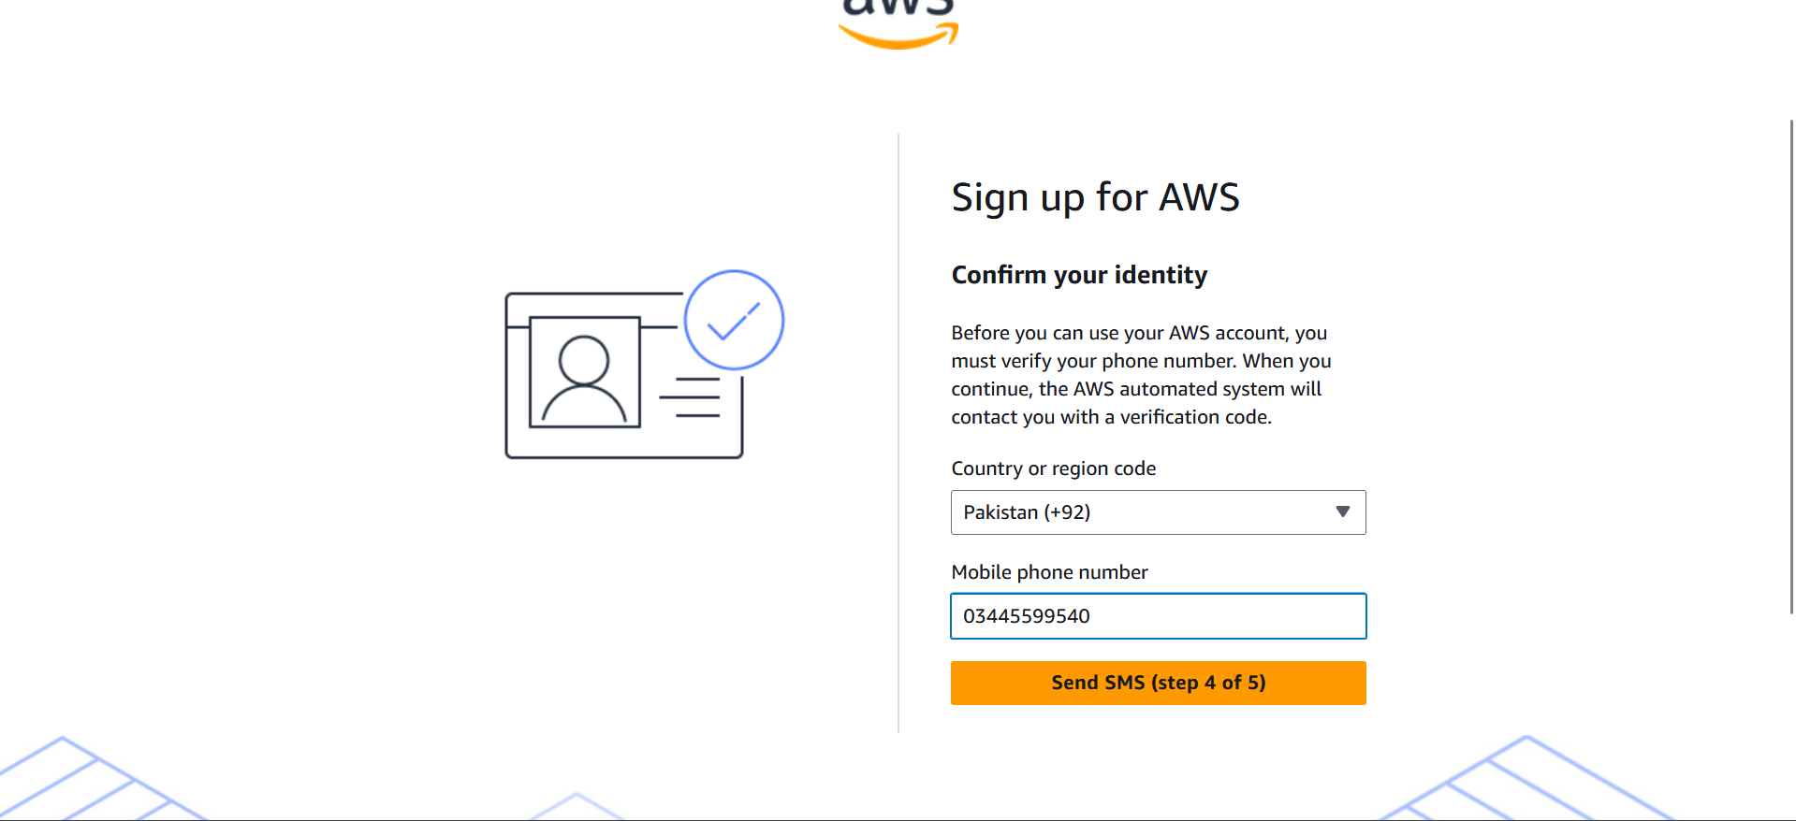

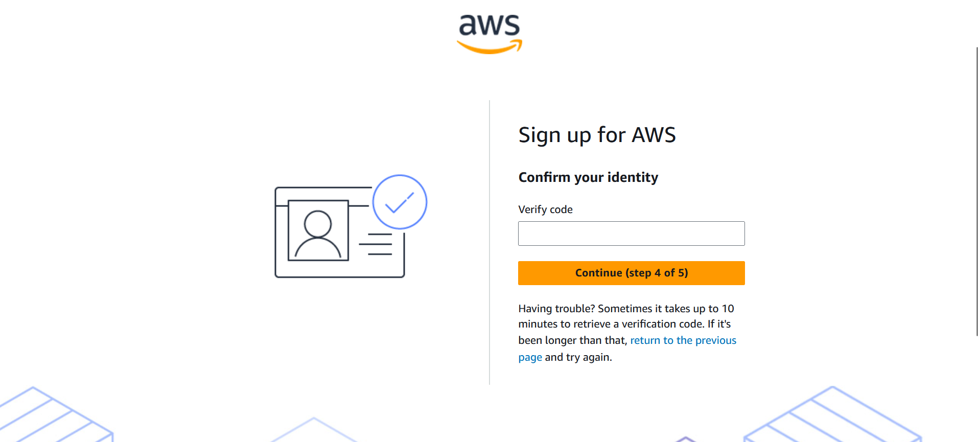

From the Console, open the region selector and enable UAE (me-central-1), then switch to me-central-1. Capture the change: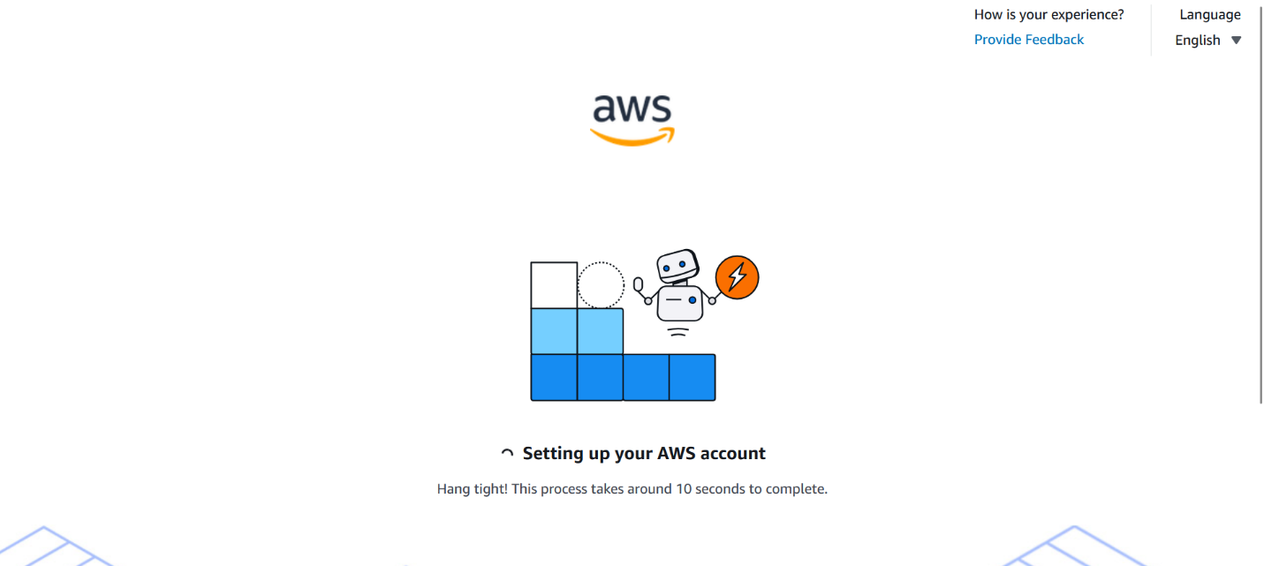

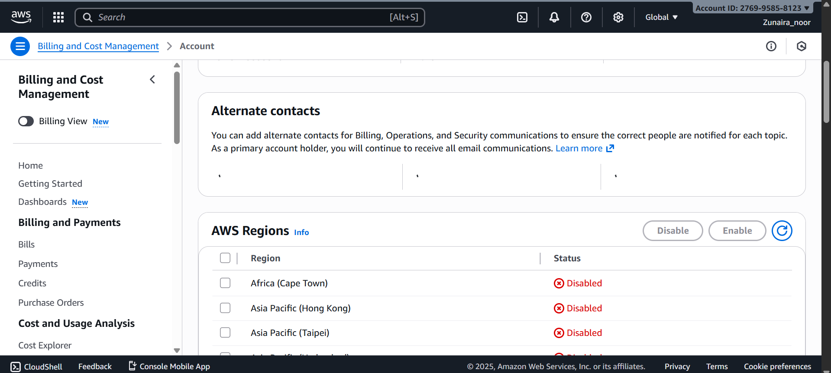

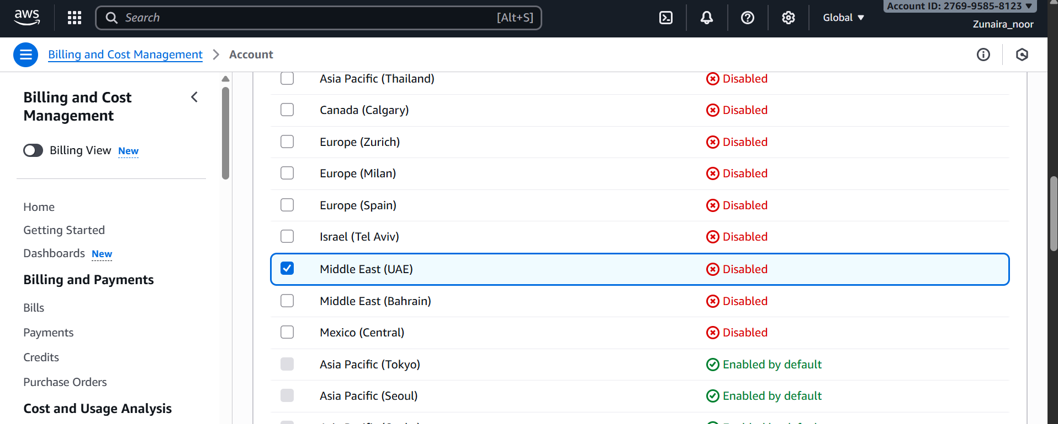

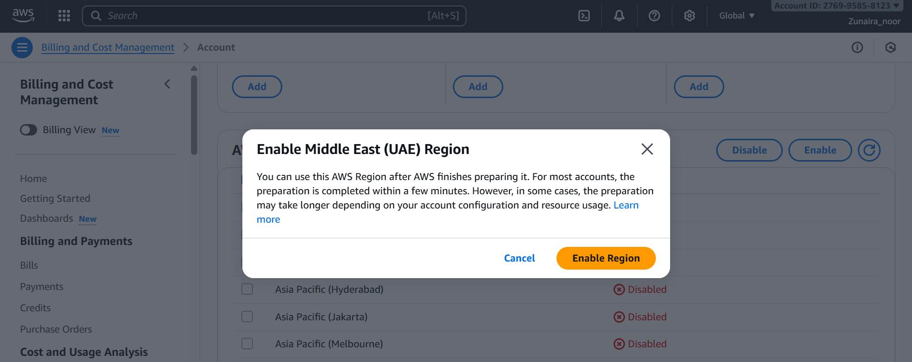

Task 1 summary screenshot (combine evidence):

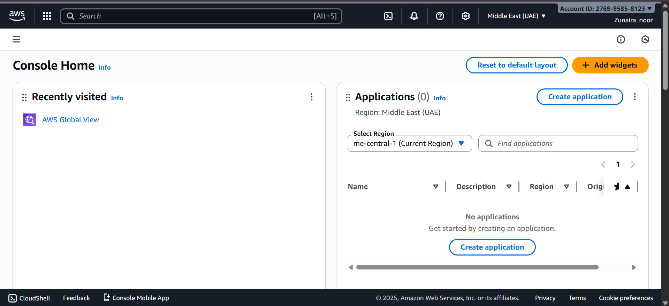

**Task 2 — Create IAM Admin and Lab8User with console access**

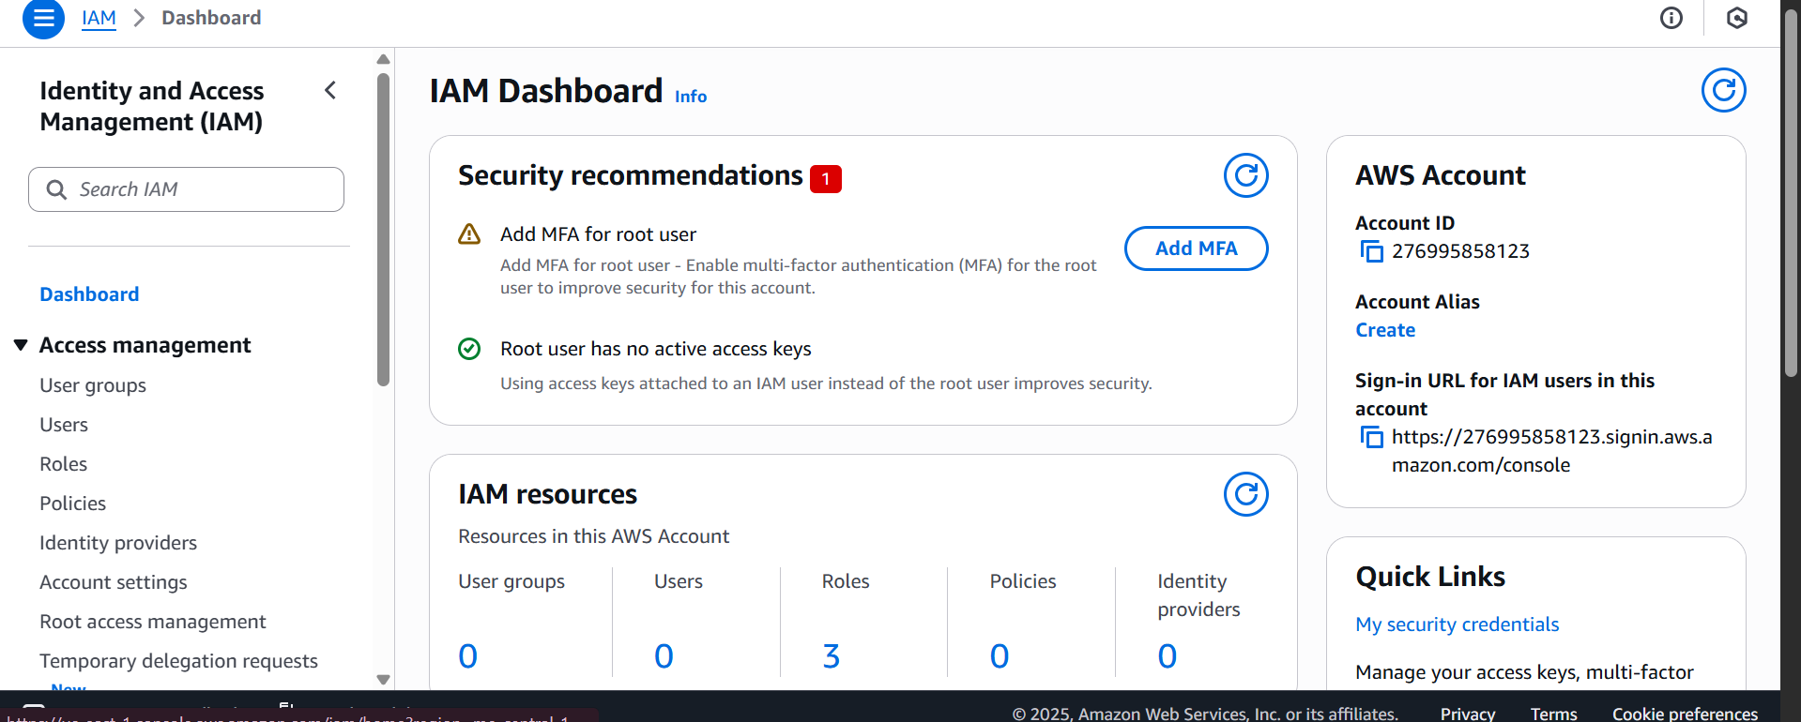

Create the Admin user: IAM → Users → Create user. Fill:

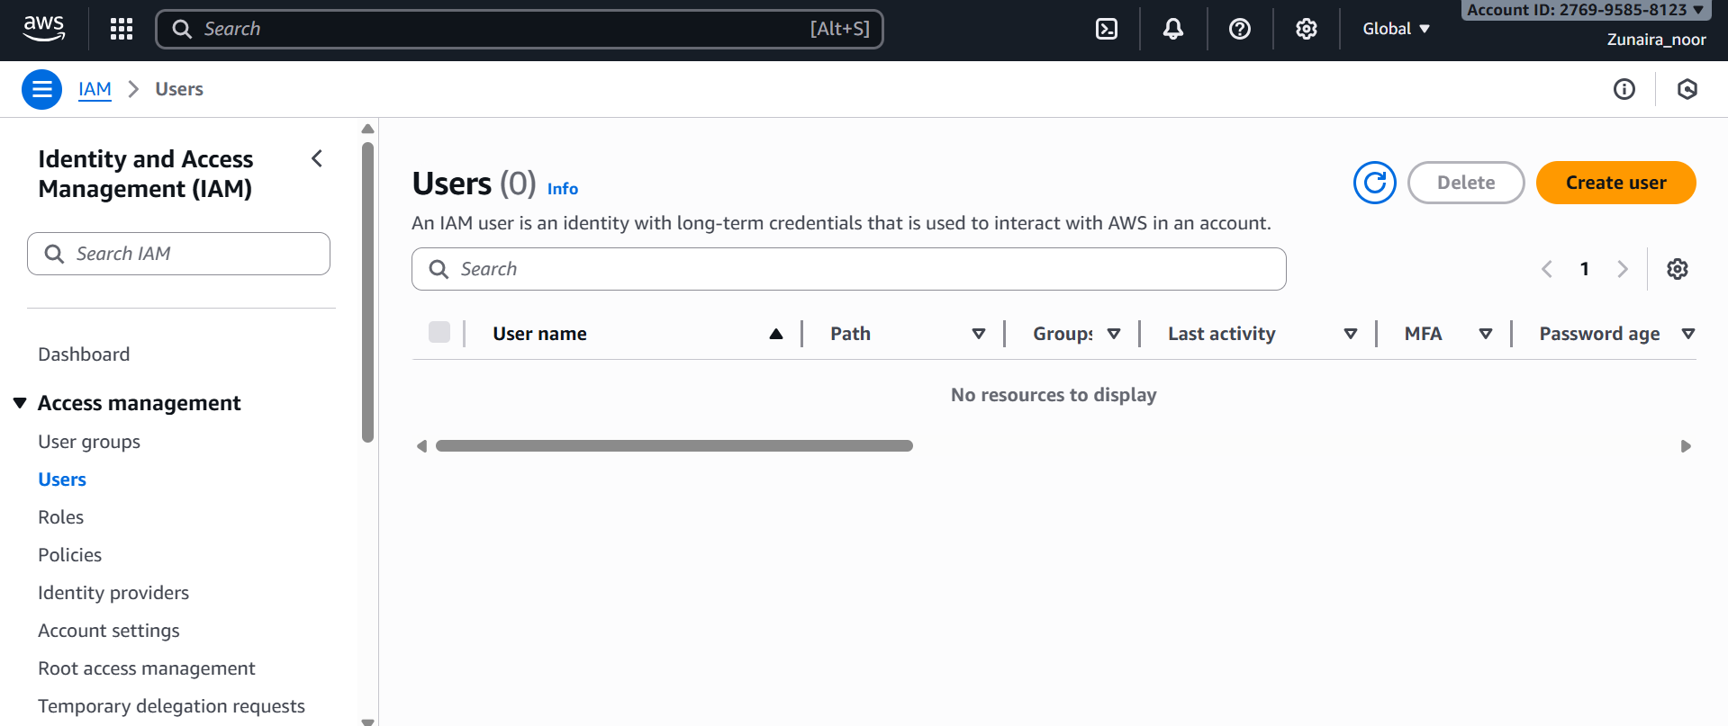

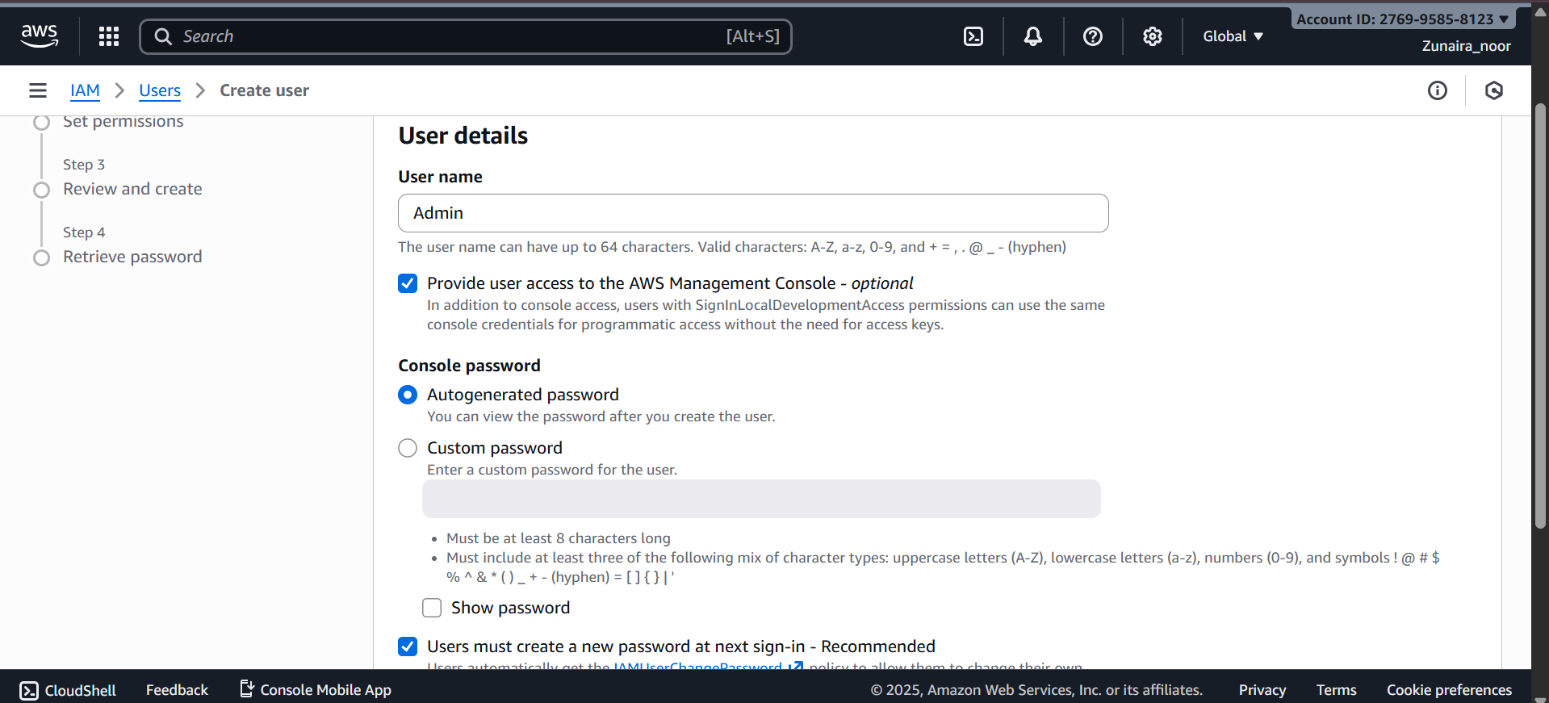

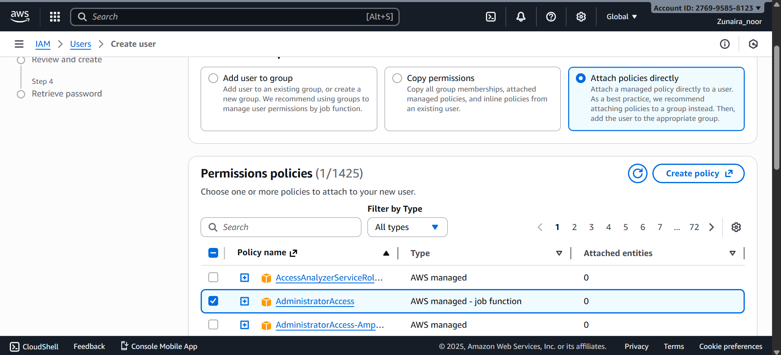

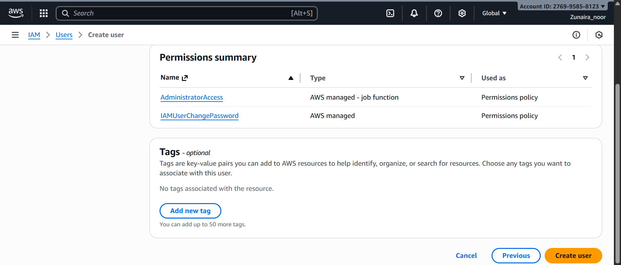

Download the Admin .csv and show its presence on your Windows host (do not display the password text):

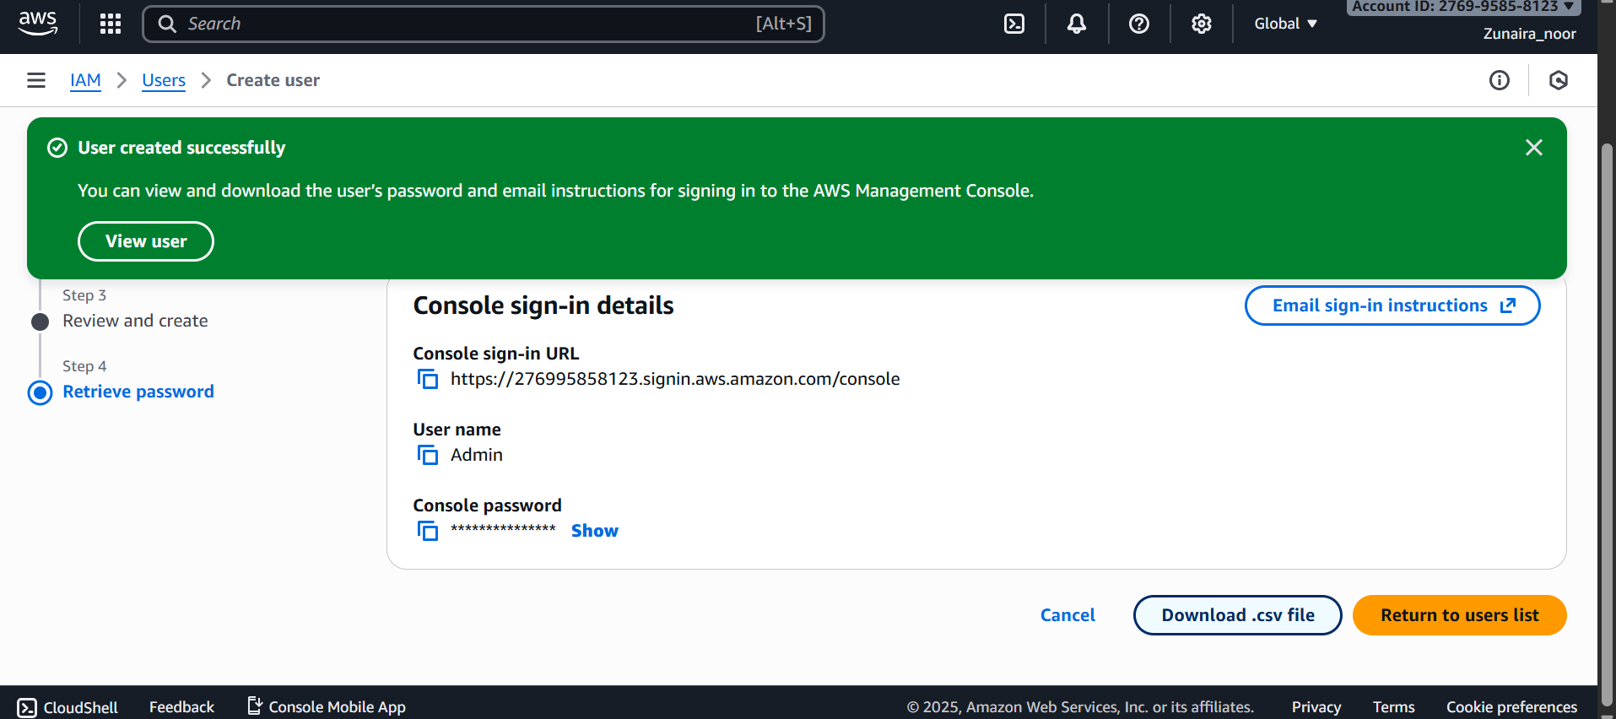



Sign out of root, then sign in using the Admin account (use the signin URL from the .csv). Capture after successful Admin login:

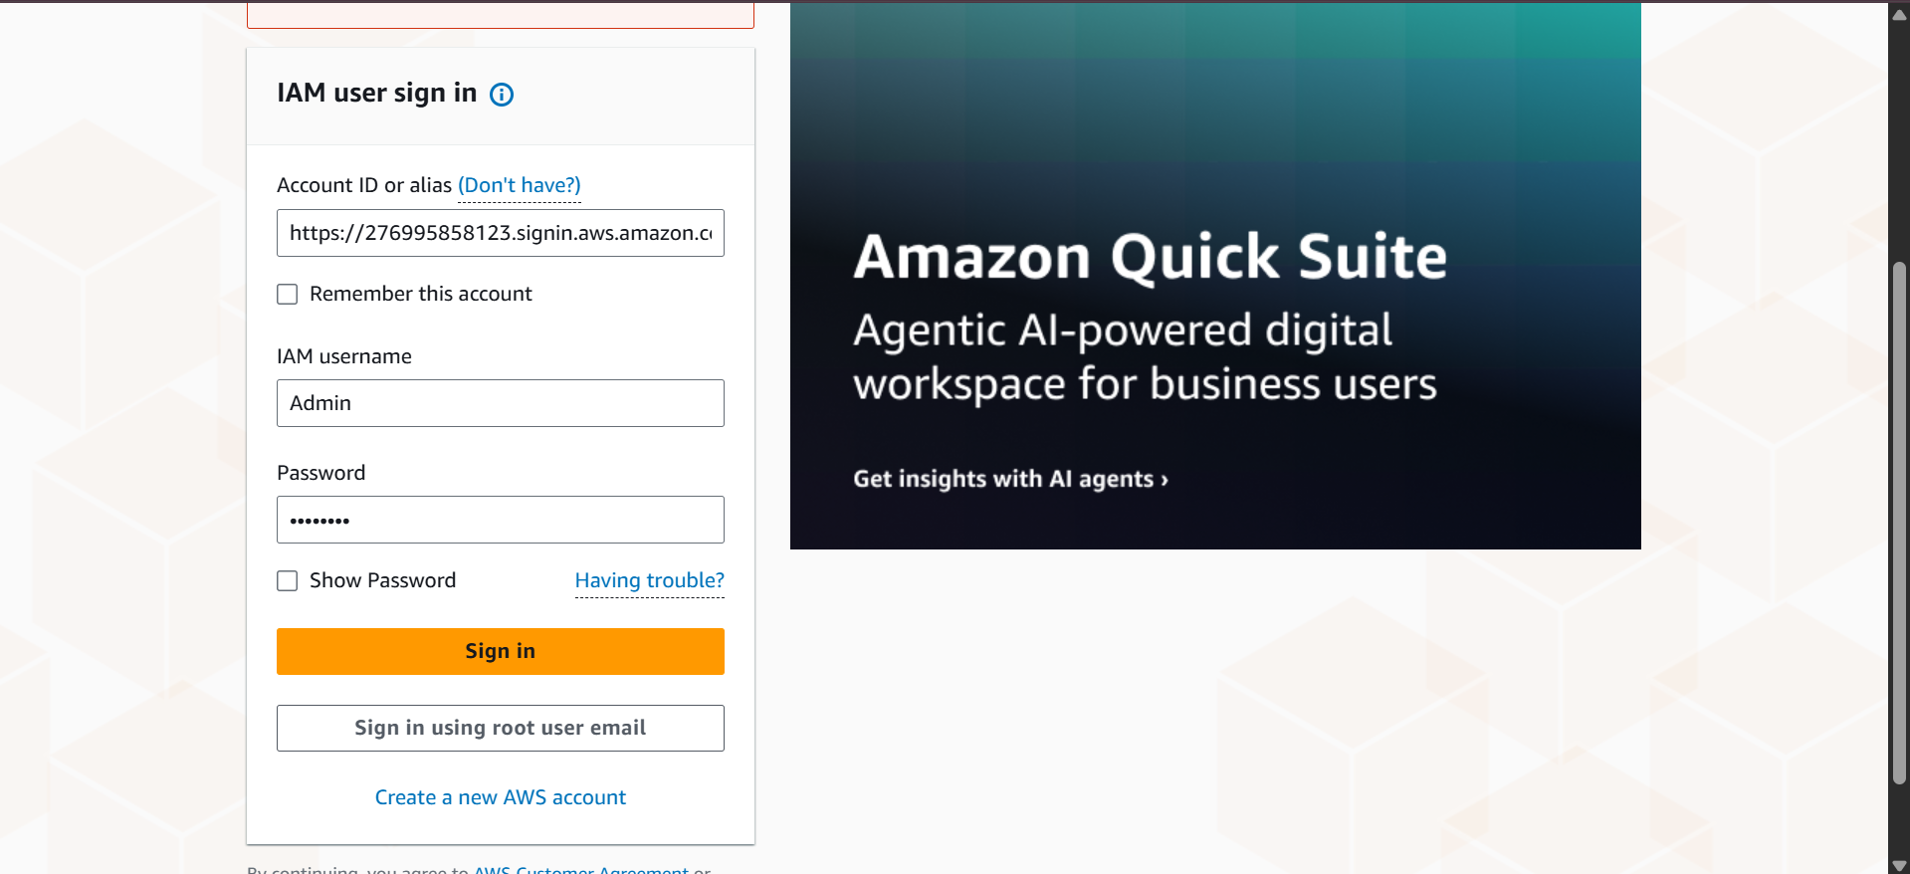

While logged in as Admin, create Lab8User:

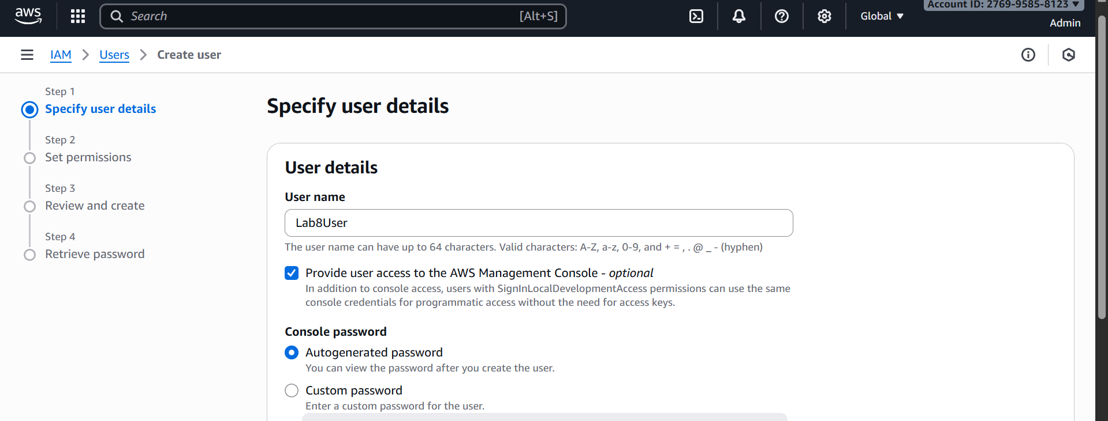

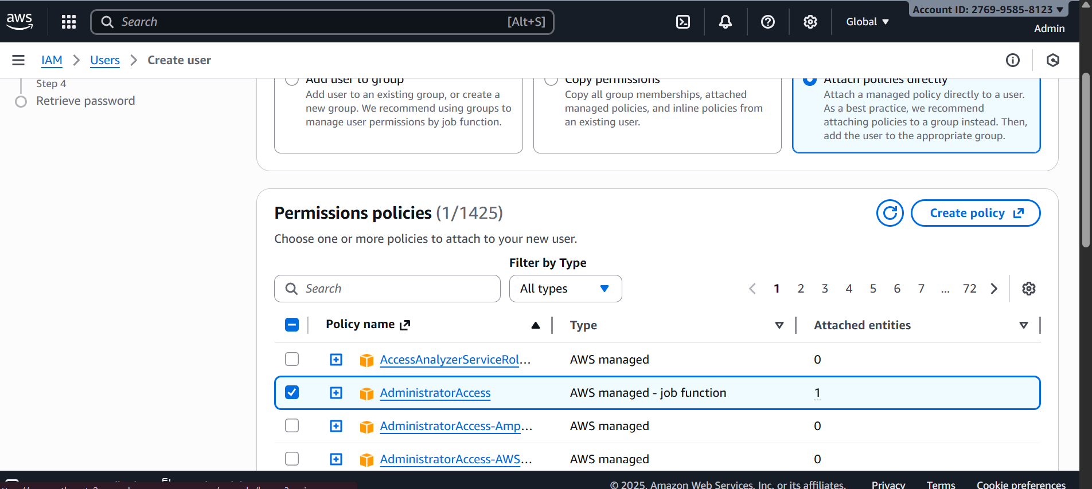

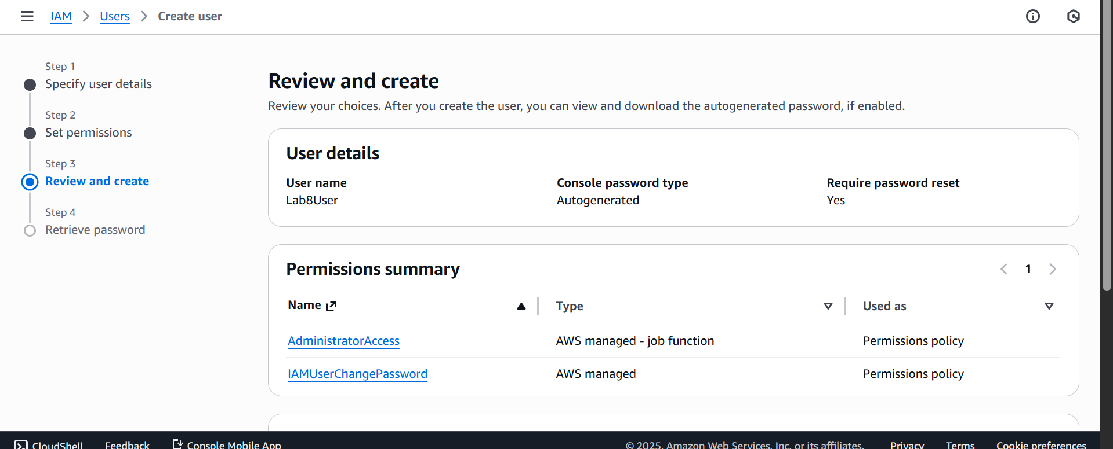

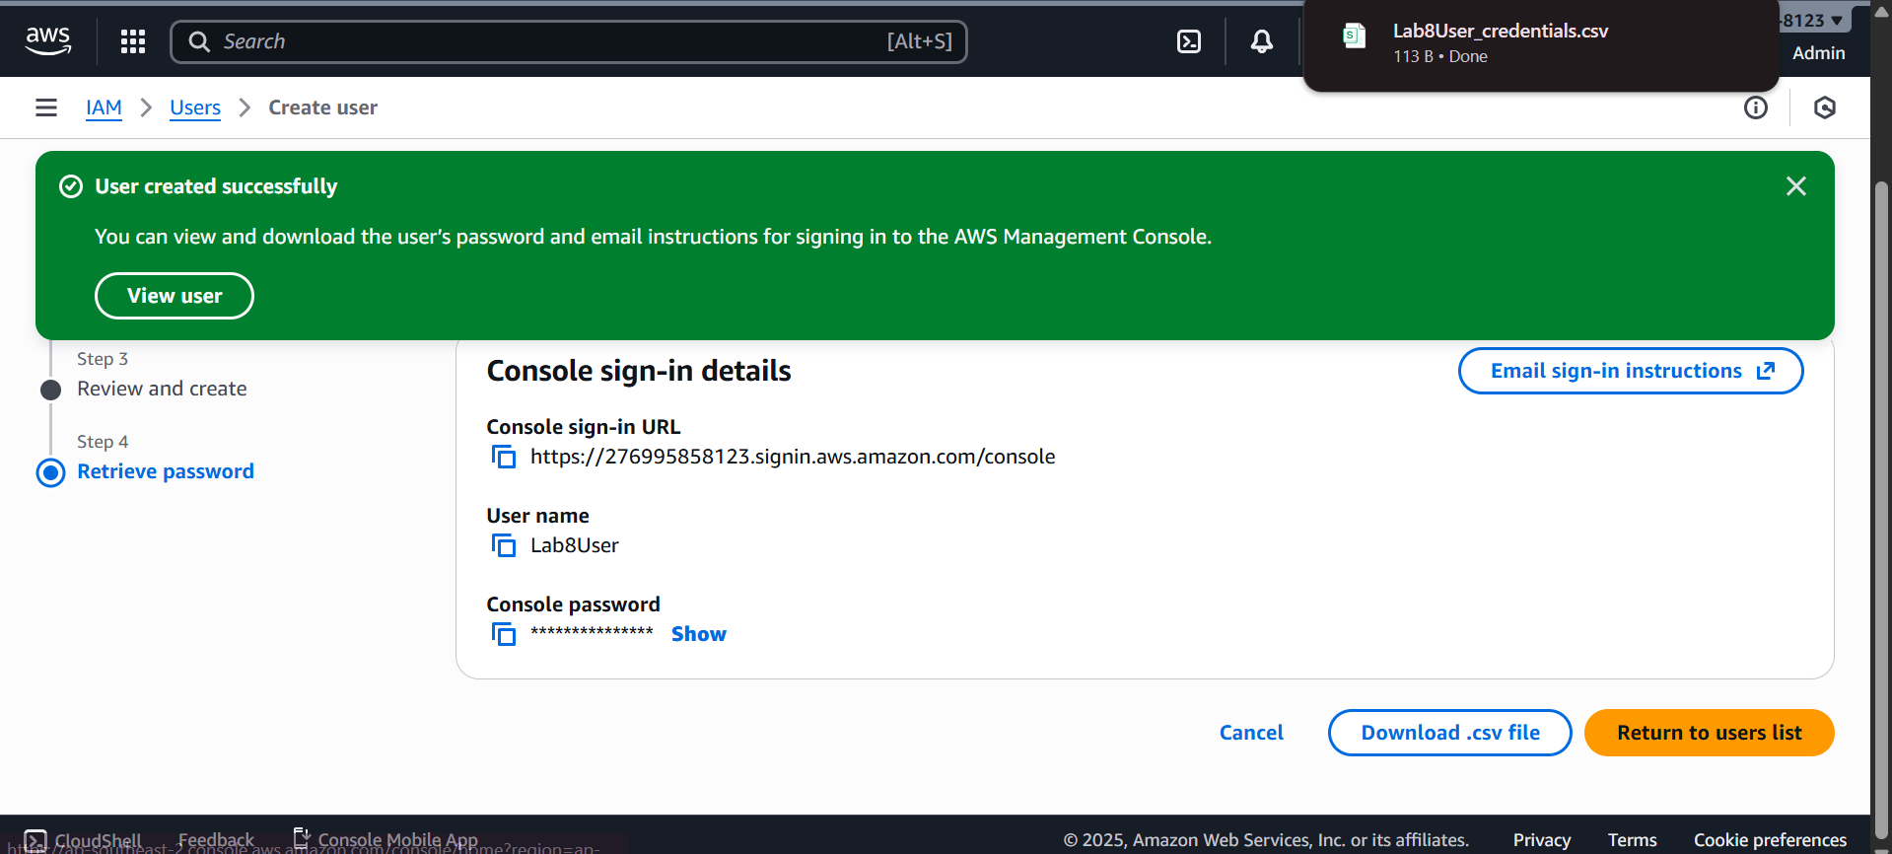

Download/save the Lab8User CSV on your Windows host (do not show password).

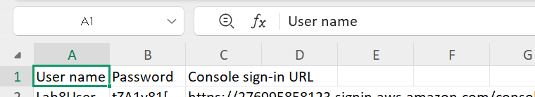

Logout Admin and login as Lab8User (use the Lab8User signin URL and credentials). Capture after login:

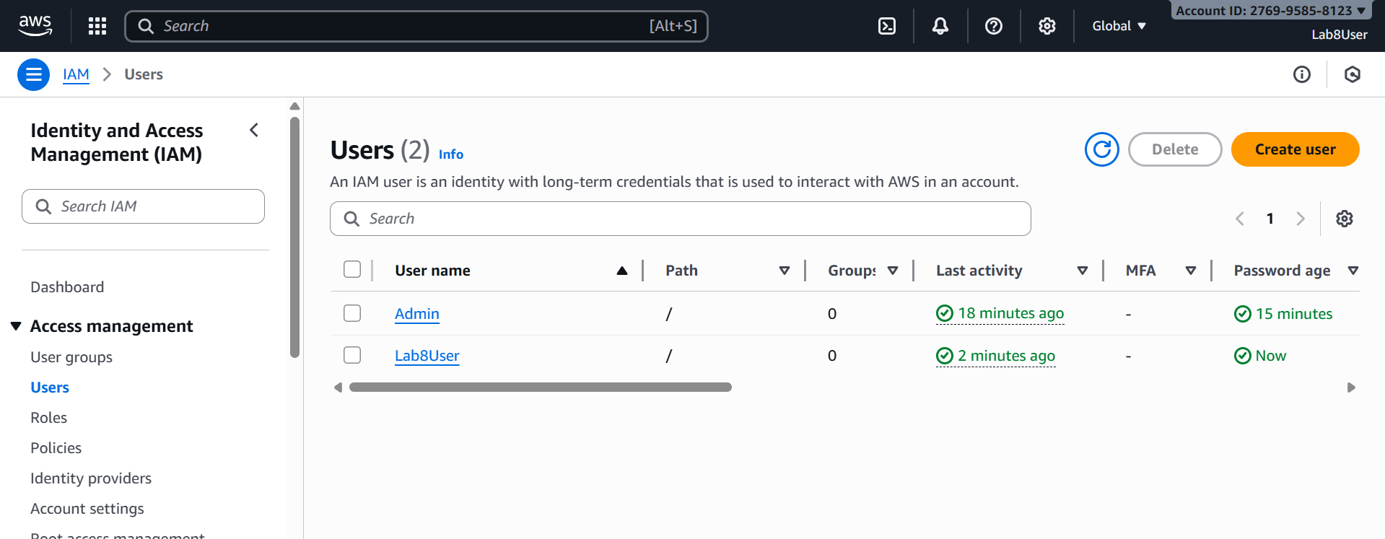

**Task 3 — Inspect VPC resources (in UAE me-central-1)**

Open VPC console (Alt+S → "VPC") while region is me-central-1.

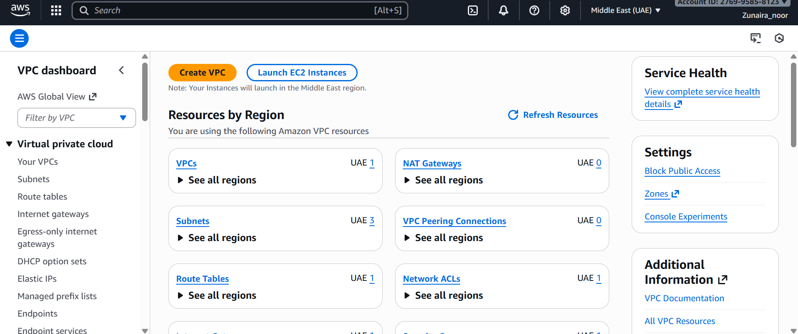

View VPCs list. Capture:

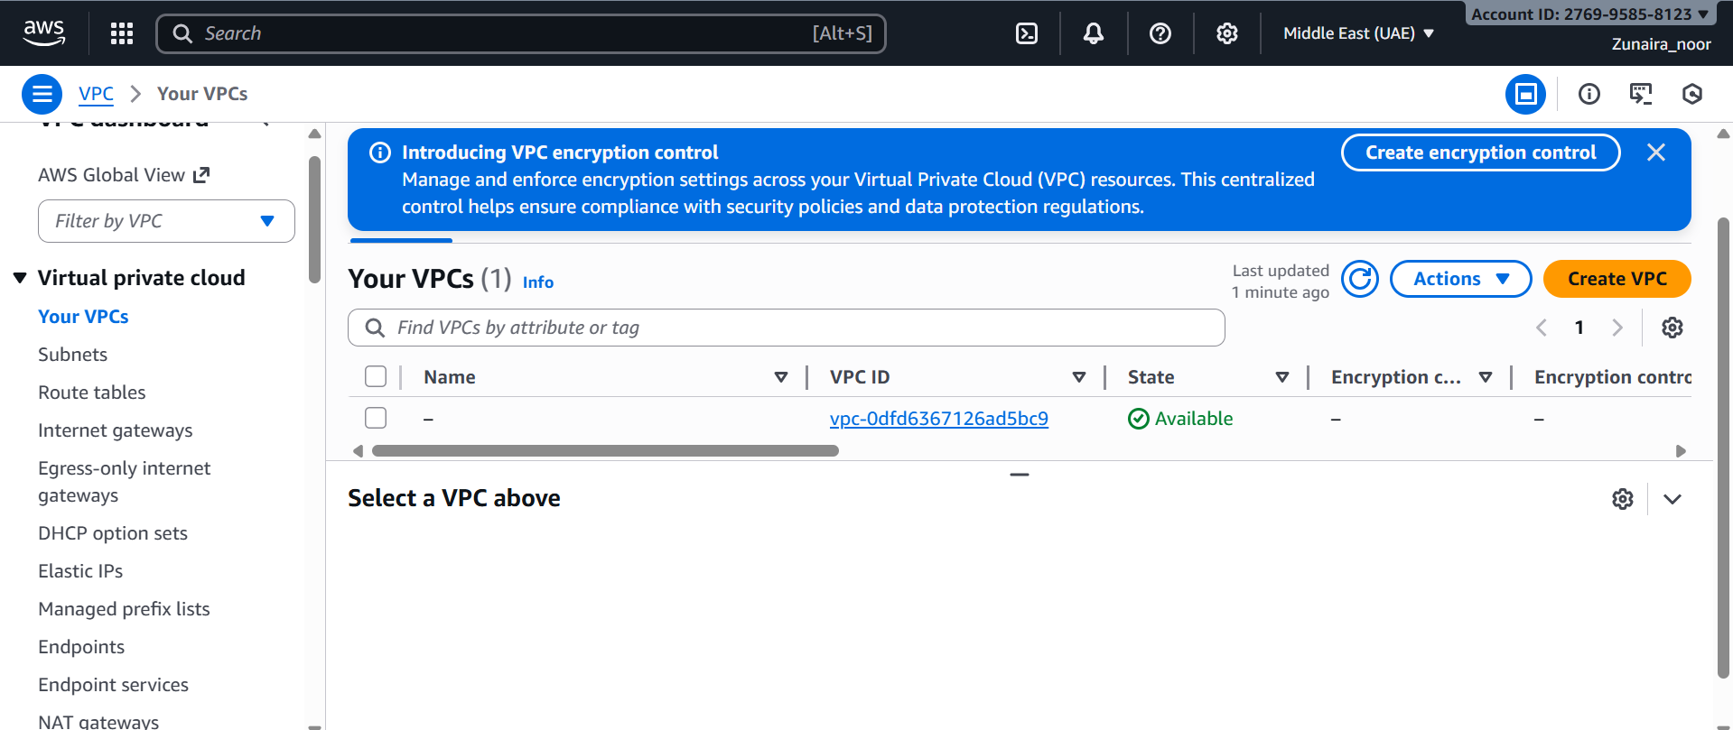

View Subnets list. Capture:

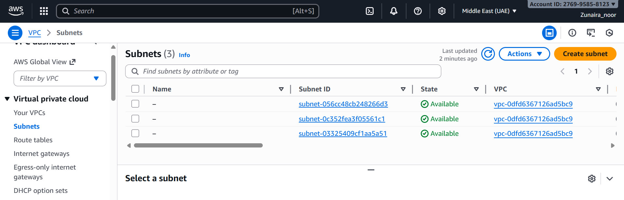

View Route Tables list. Capture:

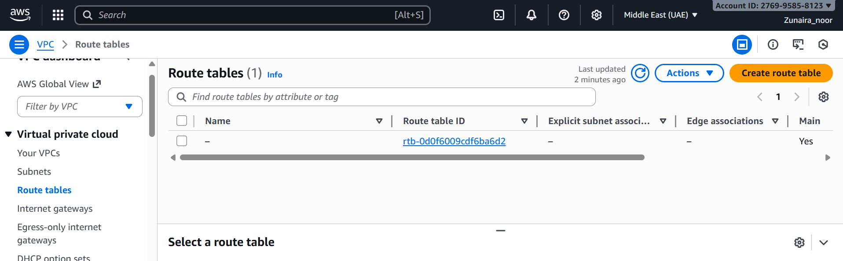

View Network ACLs list. Capture:

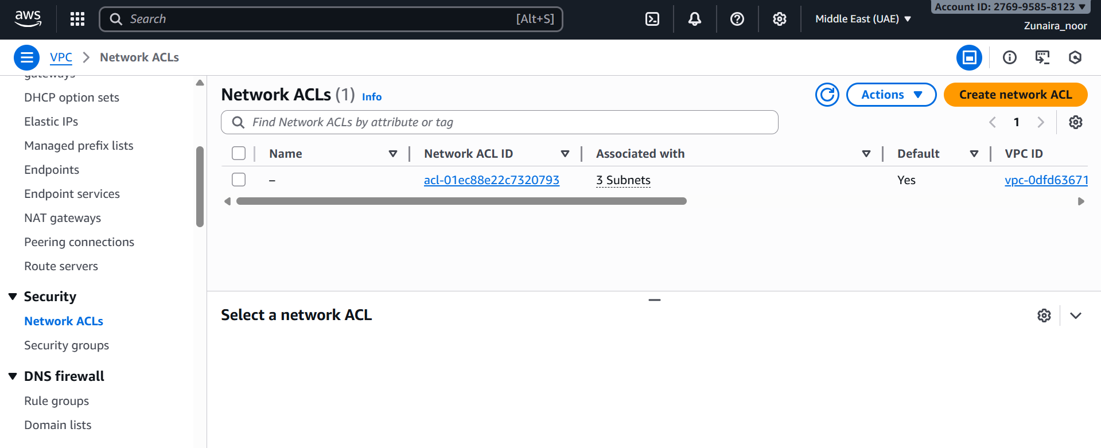

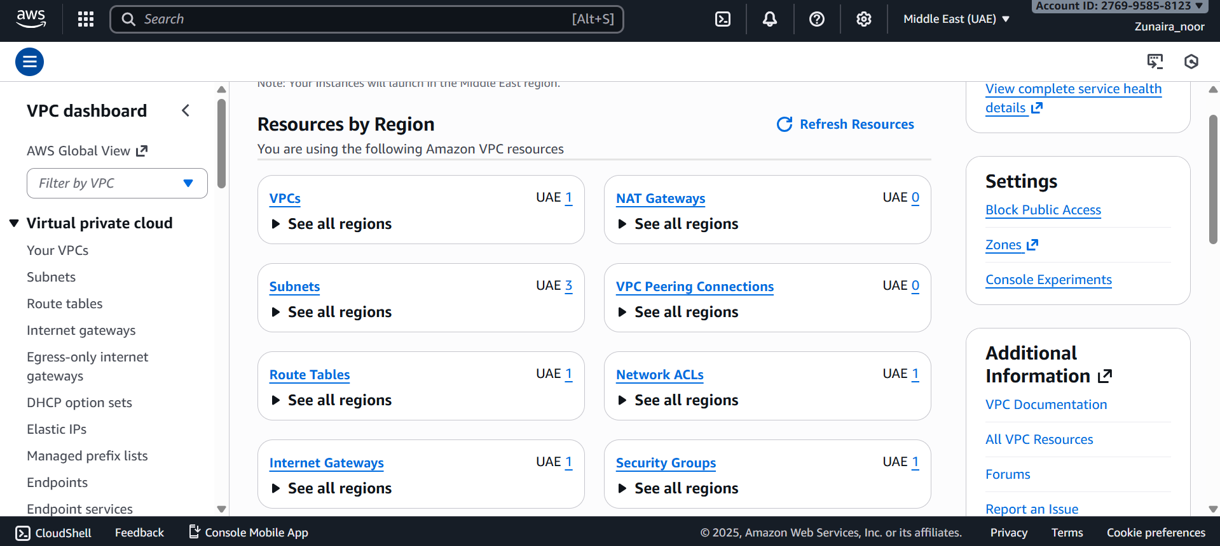

**Task 4 — Launch EC2, SSH, install Docker & Docker Compose, deploy Gitea**

Open EC2 Console (Alt+S → "EC2") (me-central-1).

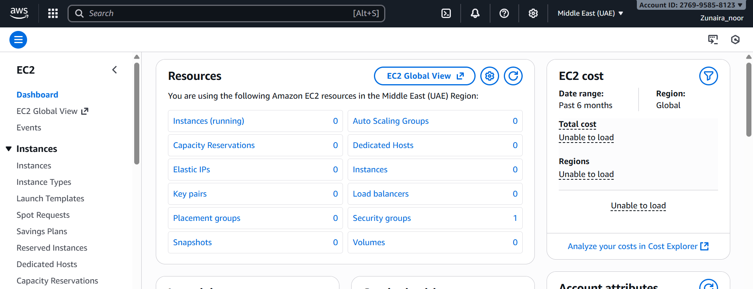

Instance Launch configuration (during review before launching). Configure:

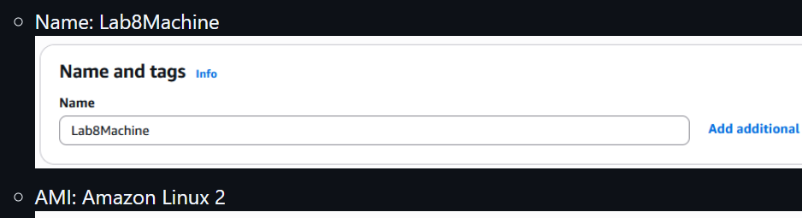

AMI: Amazon Linux 2

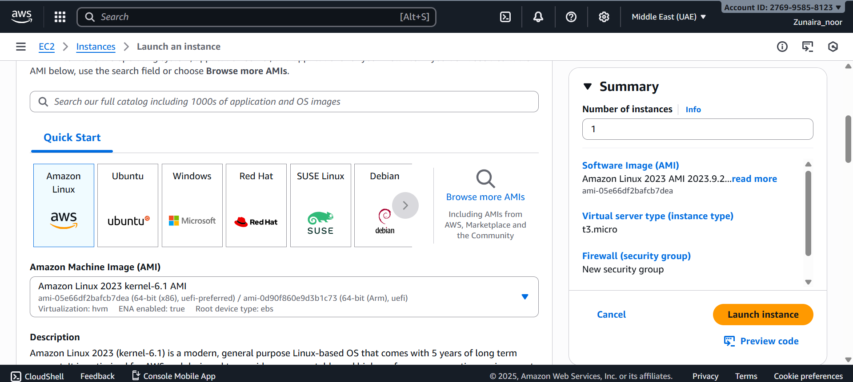

Instance type: t2.micro

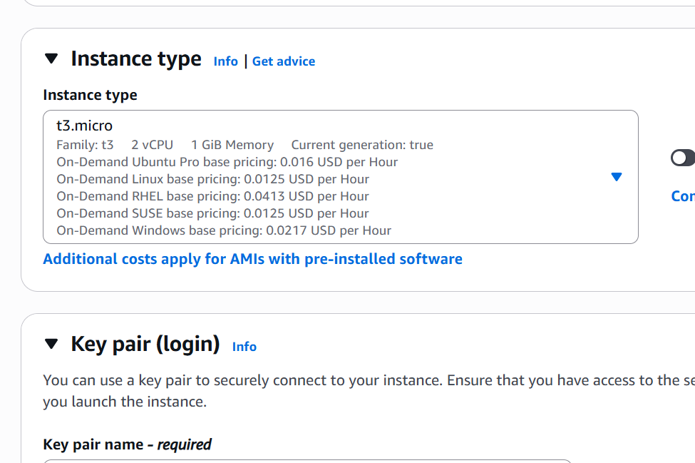

Security group: Create Lab8SecurityGroup with SSH from My IP

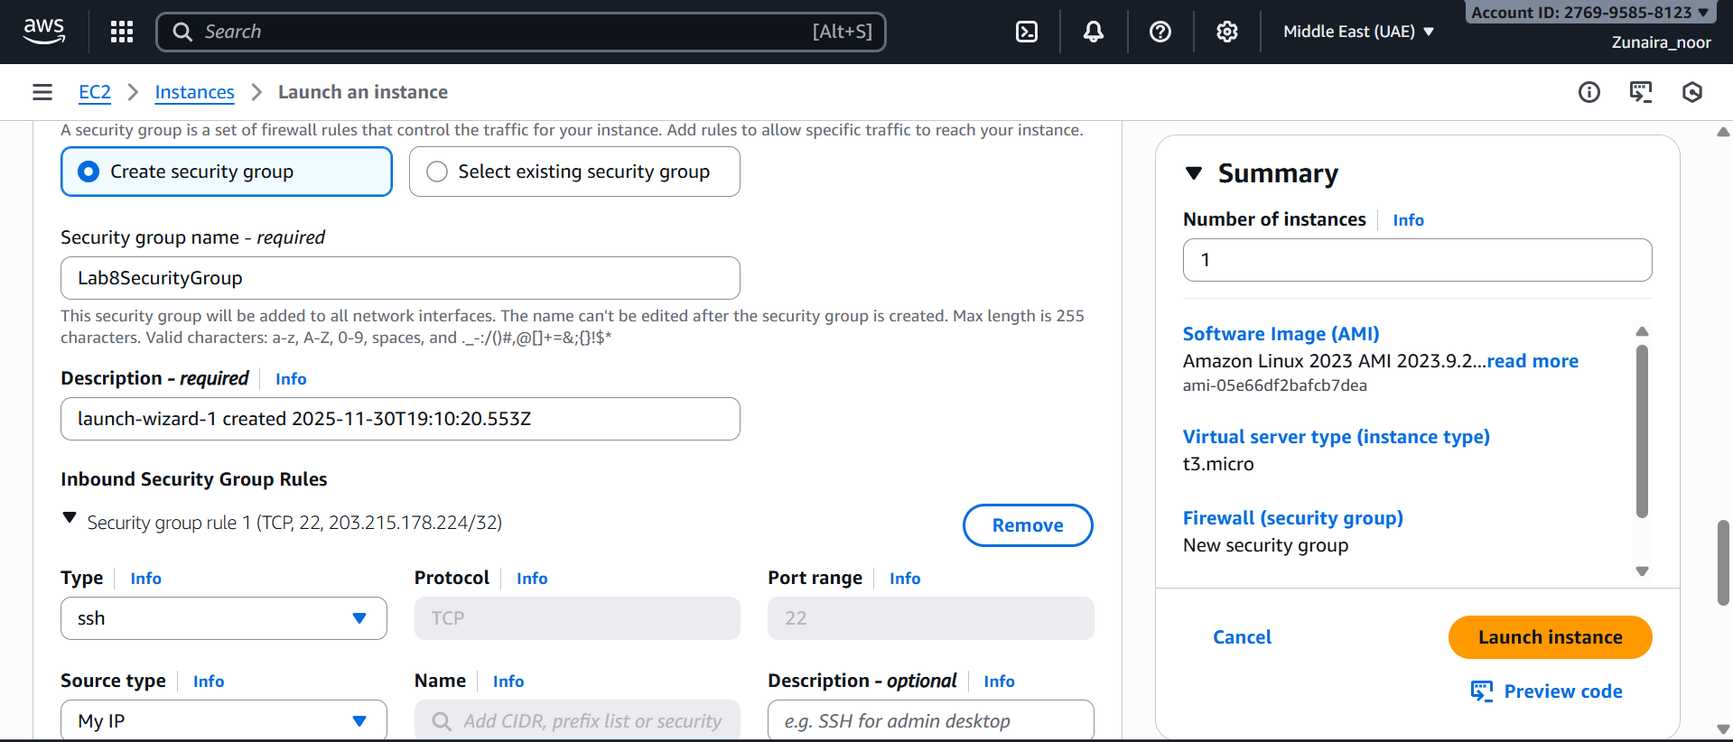

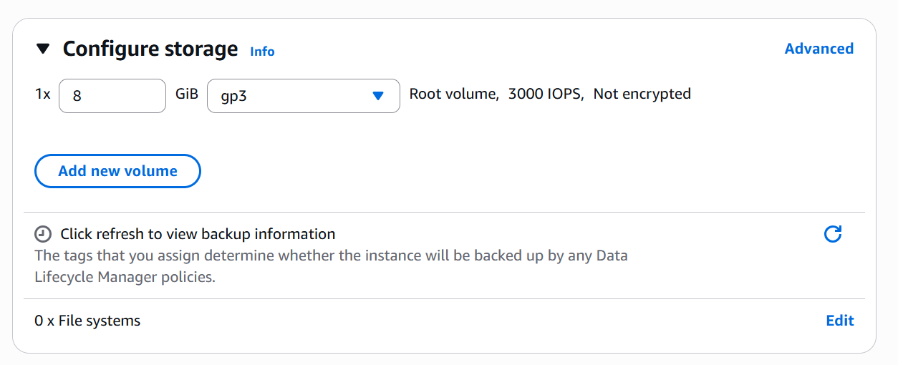

Key pair: Create Lab8Key (ED25519, .pem) and download the .pem file to your Windows host

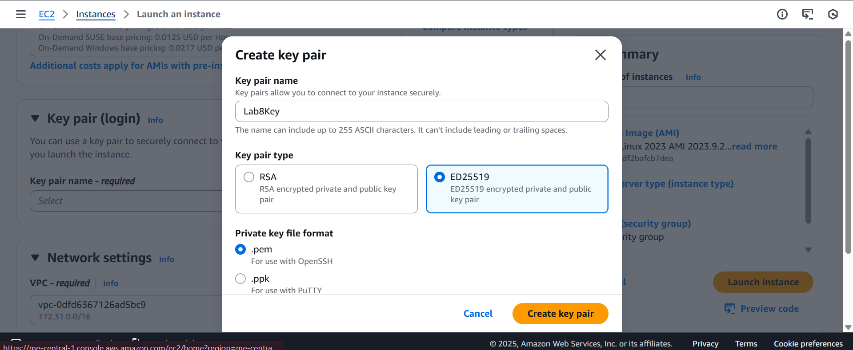

 final review page showing instance name, AMI, type, security group, key pair.

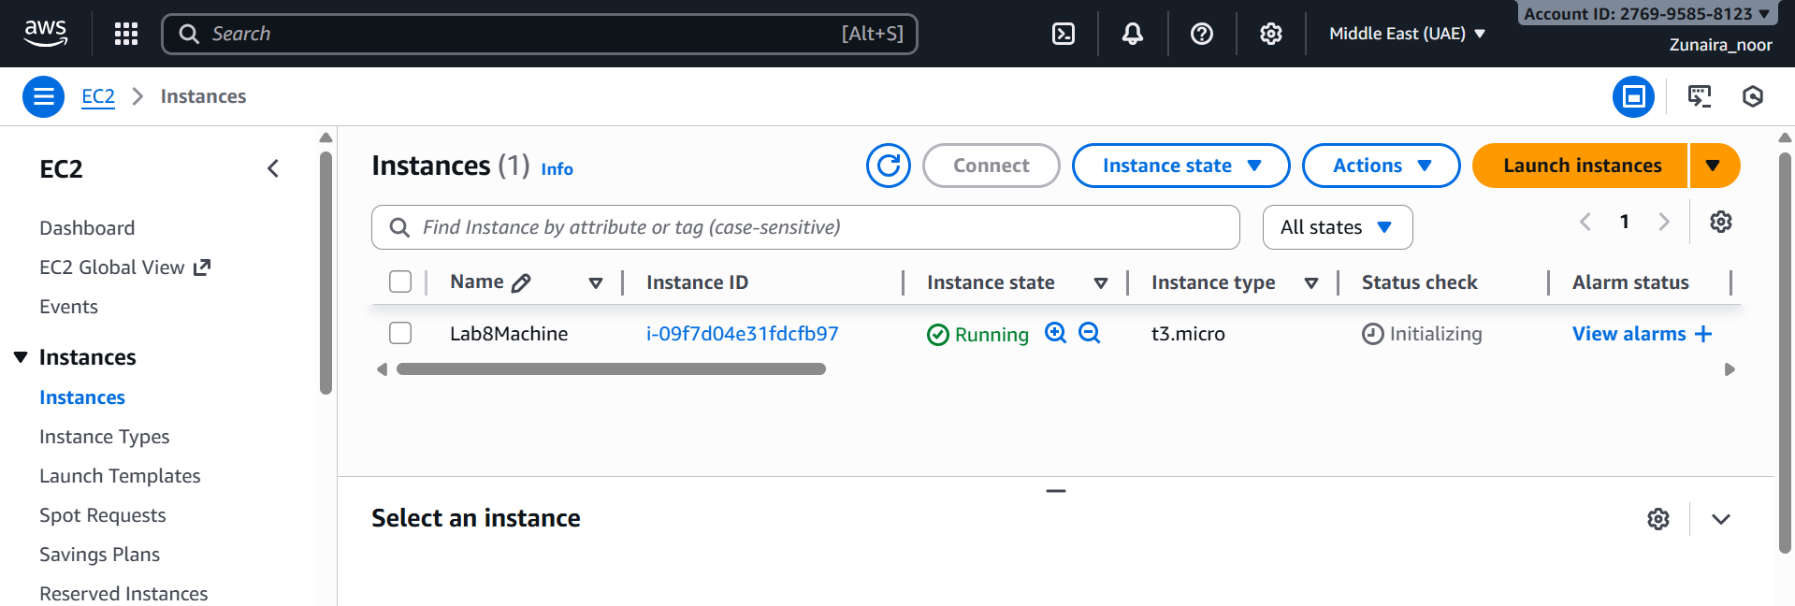

 final review page showing instance name, AMI, type, security group, key pair.

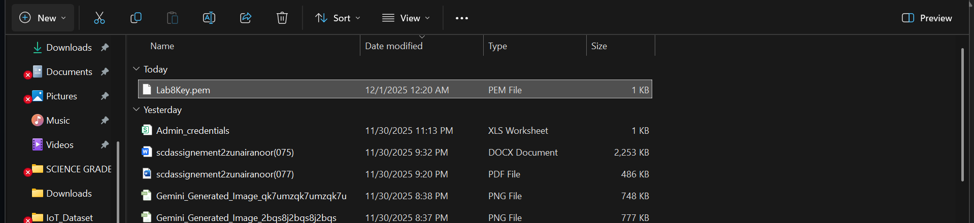

After launch, EC2 Instances list showing Lab8Machine in "running" state and public IPv4 visible.

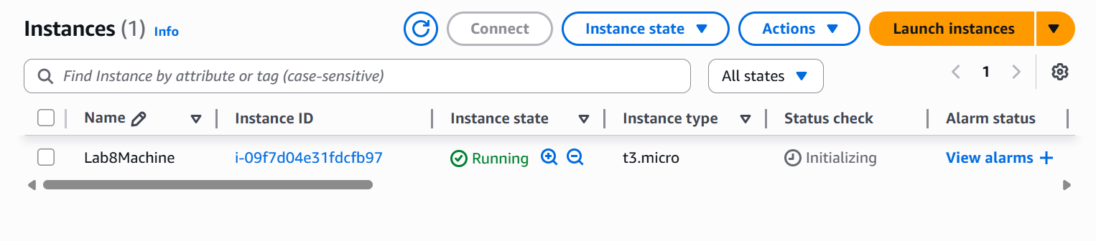

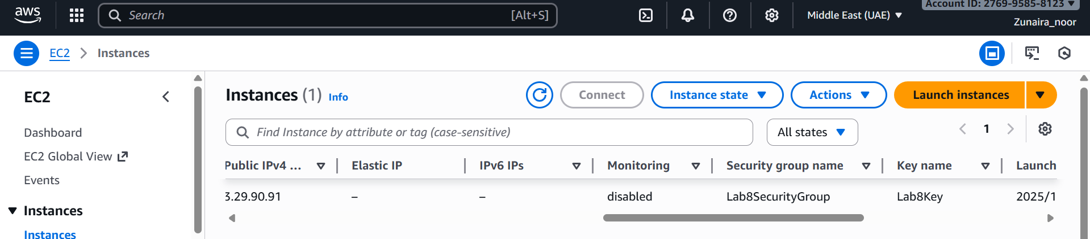

On Windows host, run SSH using the downloaded .pem (PowerShell/Git Bash)

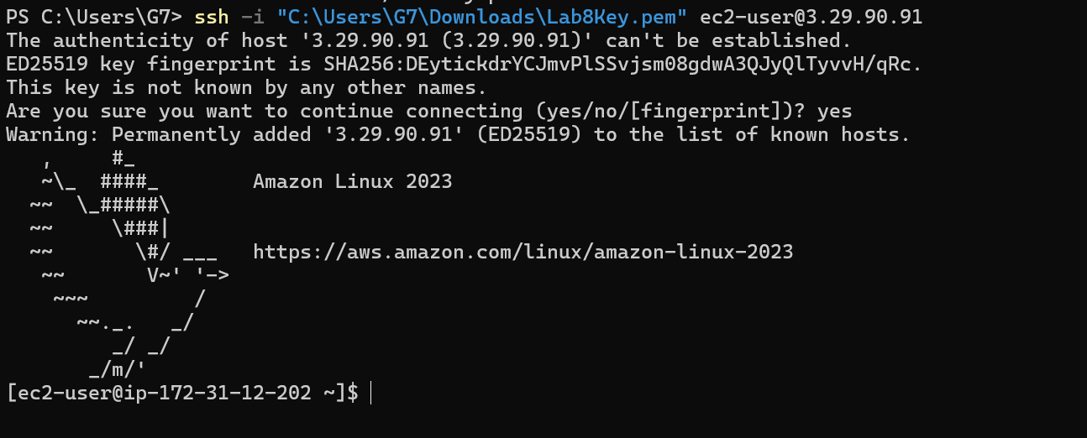

Run the install commands on the EC2 shell:

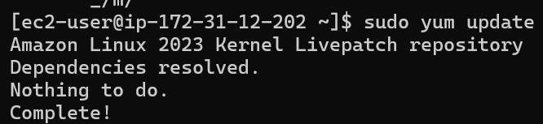

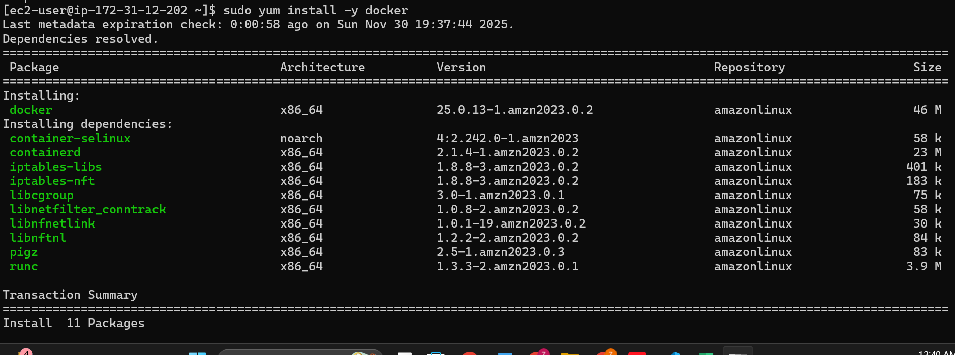

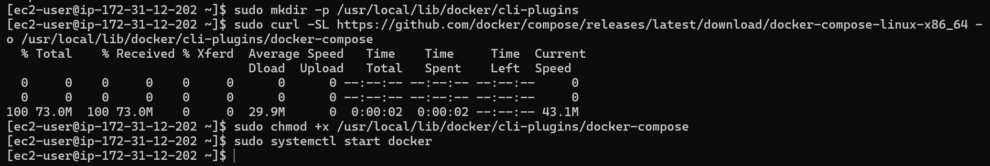

Create/edit compose.yaml on the EC2 instance (sudo vim compose.yaml) and paste content from the repo: [Gitea](https://github.com/WaqasSaleem97/Gitea) . While pasting, capture the editor content:

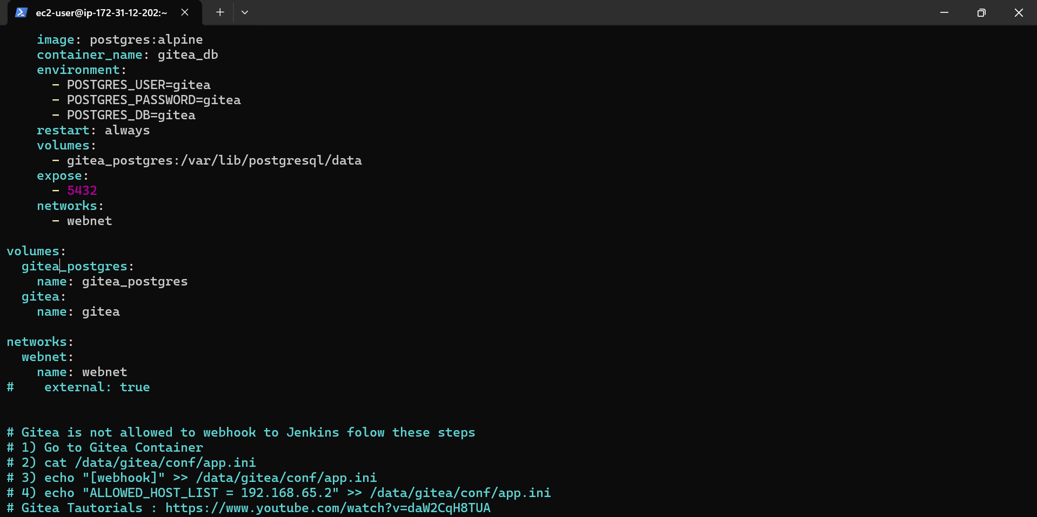

Save and verify file exists:

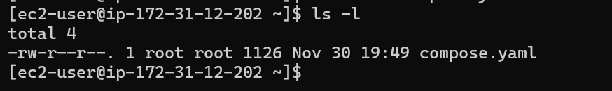

Add ec2-user to docker group, show groups before re-login, exit and reconnect, show groups after reconnect:

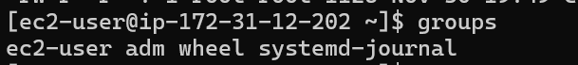

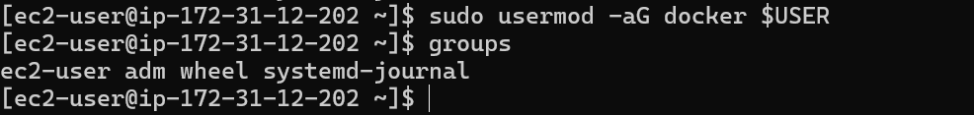

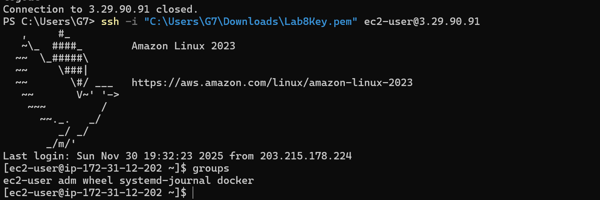

Run docker compose up -d from the directory with compose.yaml:

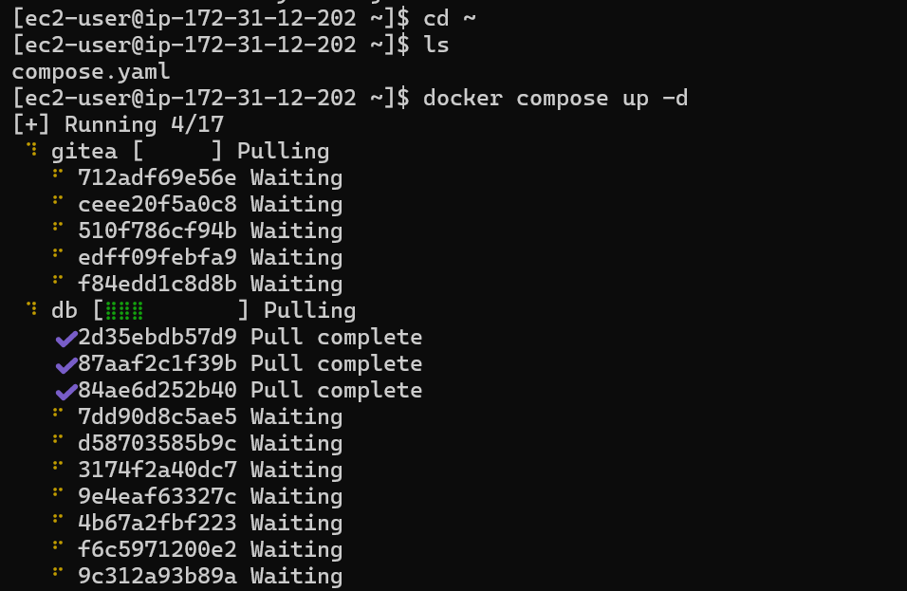

Edit the security group Lab8SecurityGroup inbound rules in the EC2 console: add Custom TCP rule port 3000 source 0.0.0.0/0 and save. Capture the inbound rules after saving:

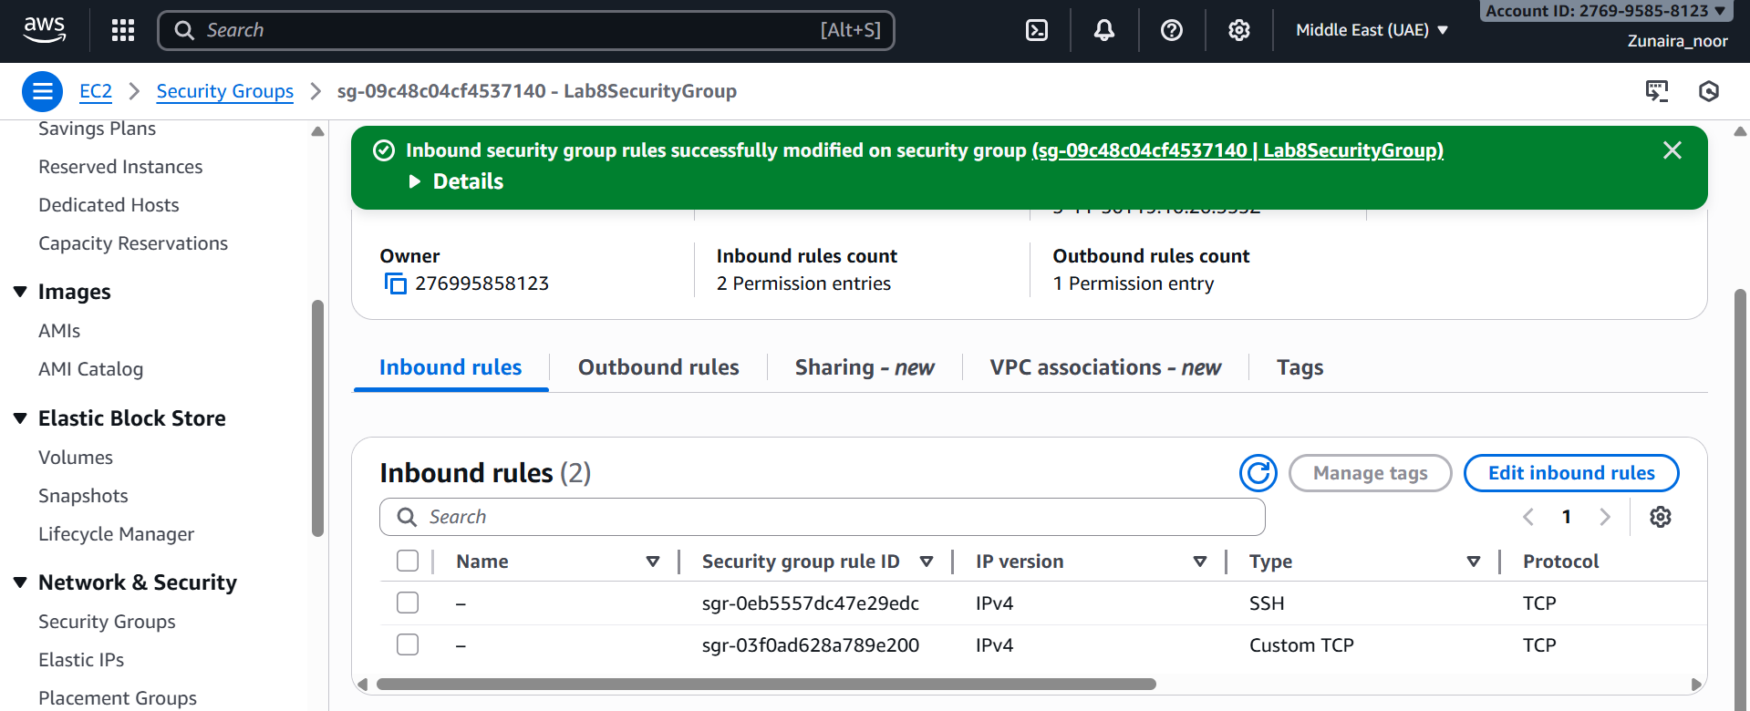

From your Windows browser navigate to: [http://Public-IP:3000](http://public-ip:3000/) — capture the Gitea setup/install page:

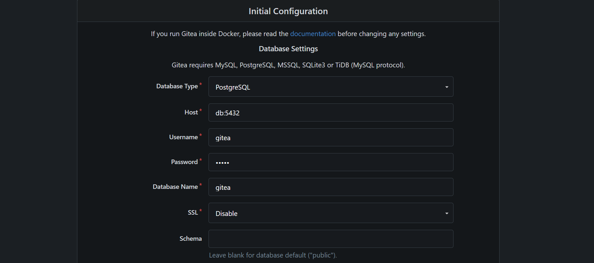

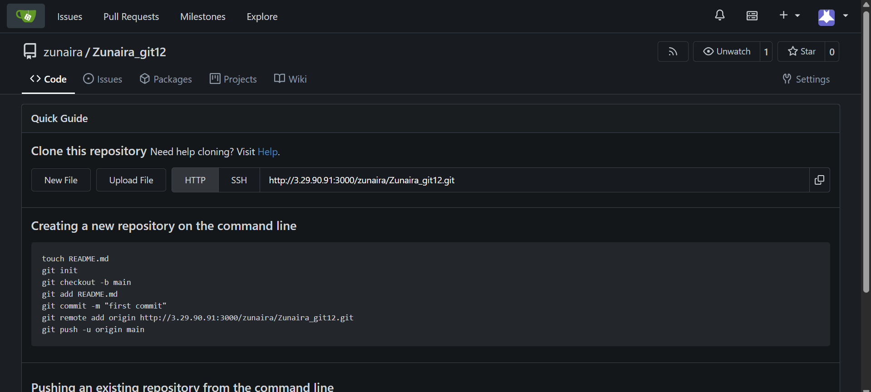

**Remove resources to avoid charges**

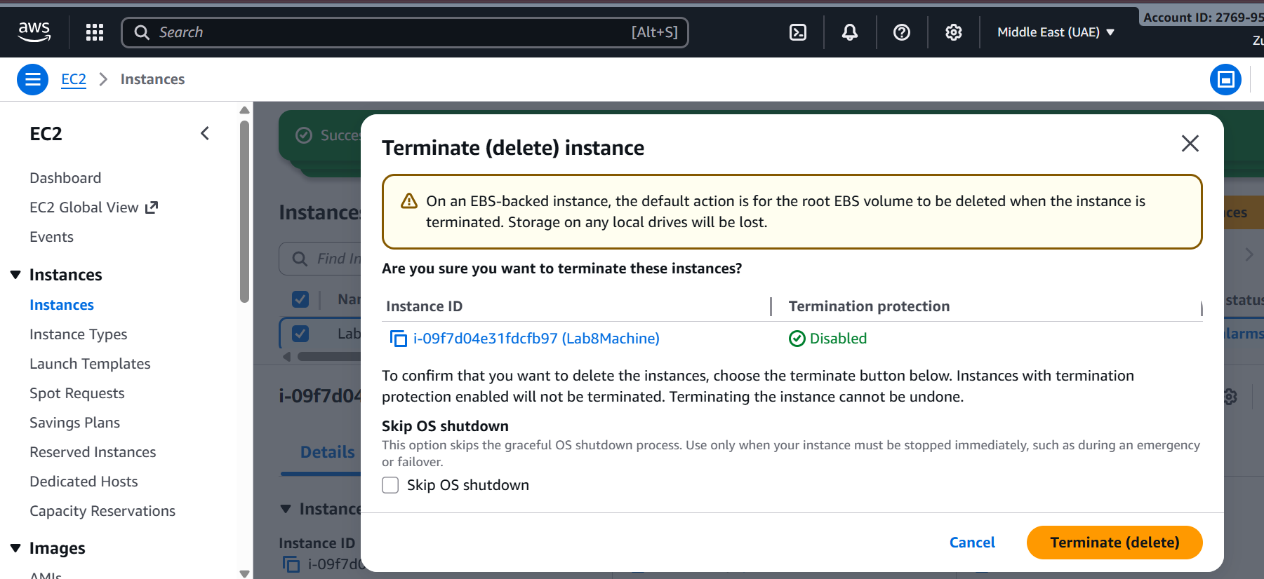

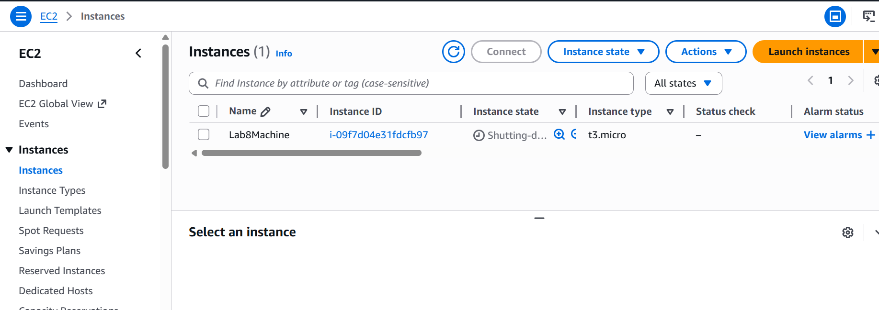

Delete associated EBS volumes and snapshots (if any).

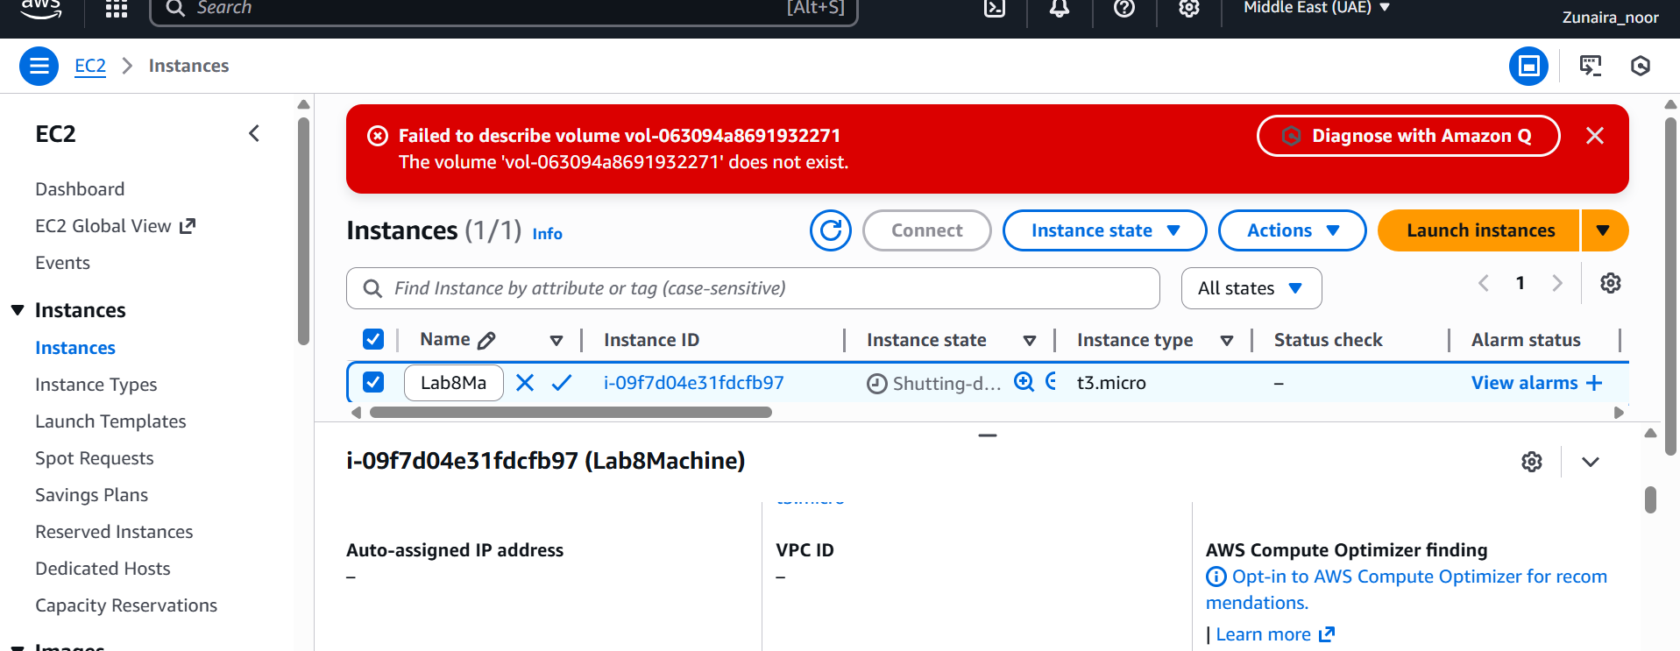

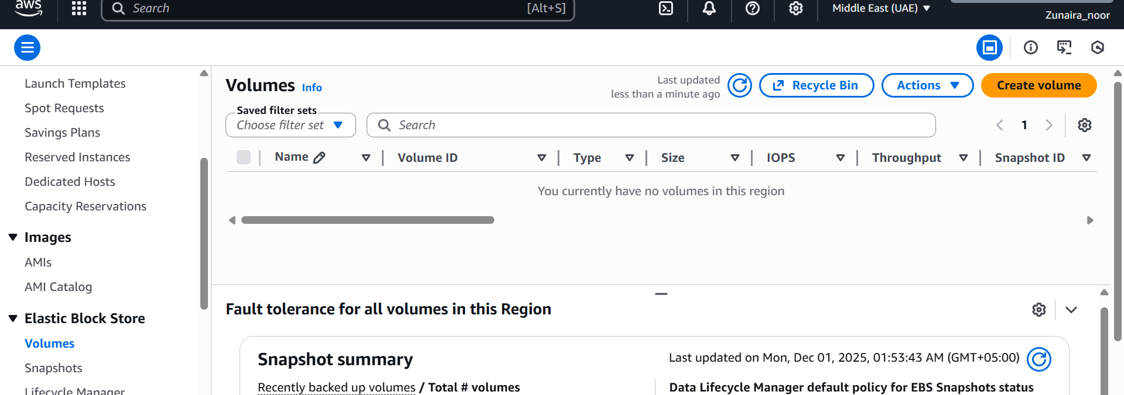

Delete security group Lab8SecurityGroup and key pair Lab8Key from the EC2 console (after instances terminated).

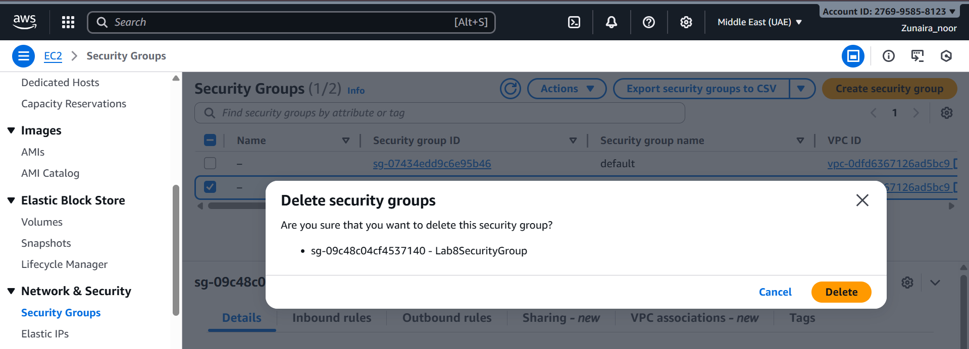

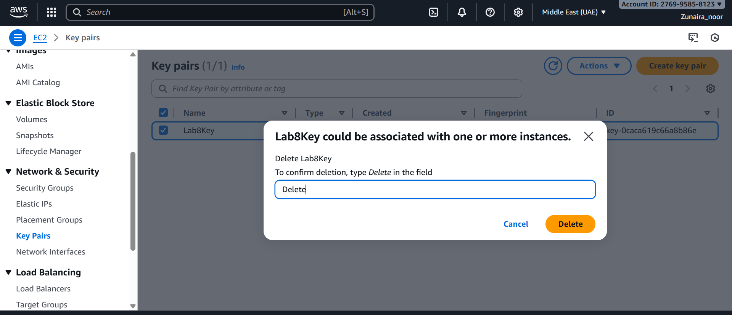

Delete IAM users Lab8User and any access keys.

